From Data to Insight: A Comprehensive Data Science Exploration Report

Introduction

Based on the provided dataset, here is a general introduction that summarizes the key information:  
  
The dataset contains 29 observations of HBGI (Hemoglobin A1C) levels and risk assessments for patients, ranging from adolescents to adults. The HBGI levels are measured in units of percentage, and the risk assessments are categorized as low, moderate, or high. The dataset also includes information on the patient's age and gender.  
  
From the dataset, we can observe that the HBGI levels vary widely among the patients, with some having lower levels (less than 5%) and others having higher levels (greater than 10%). The risk assessments also vary, with some patients categorized as low risk, while others are categorized as high or moderate risk.  
  
It is worth noting that the dataset does not provide information on the patients' medical history, medication use, or other factors that could potentially influence their HBGI levels or risk assessments. Therefore, any conclusions drawn from this dataset should be interpreted with caution, and additional information may be necessary to make more informed decisions.  
  
In summary, the dataset provides a snapshot of HBGI levels and risk assessments for a group of patients, but it is important to consider the limitations of the dataset and the potential need for additional information before making any definit

Summary Statistics

Based on the provided dataset, here are some key statistics and insights: Mean: The mean value of  
BG, CGM, CHO, and insulin is 113.15, 116.4, 6.6, and 0.028, respectively.  
 Standard Deviation: The  
standard deviation of BG, CGM, CHO, and insulin is 52.7, 52.6, 1.3, and 0.015, respectively.  
Minimum: The minimum value of BG, CGM, CHO, and insulin is 6.6, 39, 0.000001, and 0.006575,  
respectively.  
 25th Percentile: The 25th percentile of BG, CGM, CHO, and insulin is 77.5, 79.4, 39,  
and 0.010, respectively.  
 50th Percentile: The 50th percentile of BG, CGM, CHO, and insulin is  
104.5, 107.0, 40, and 0.014, respectively.  
 75th Percentile:

Most Correlated Feature Graph Analysis

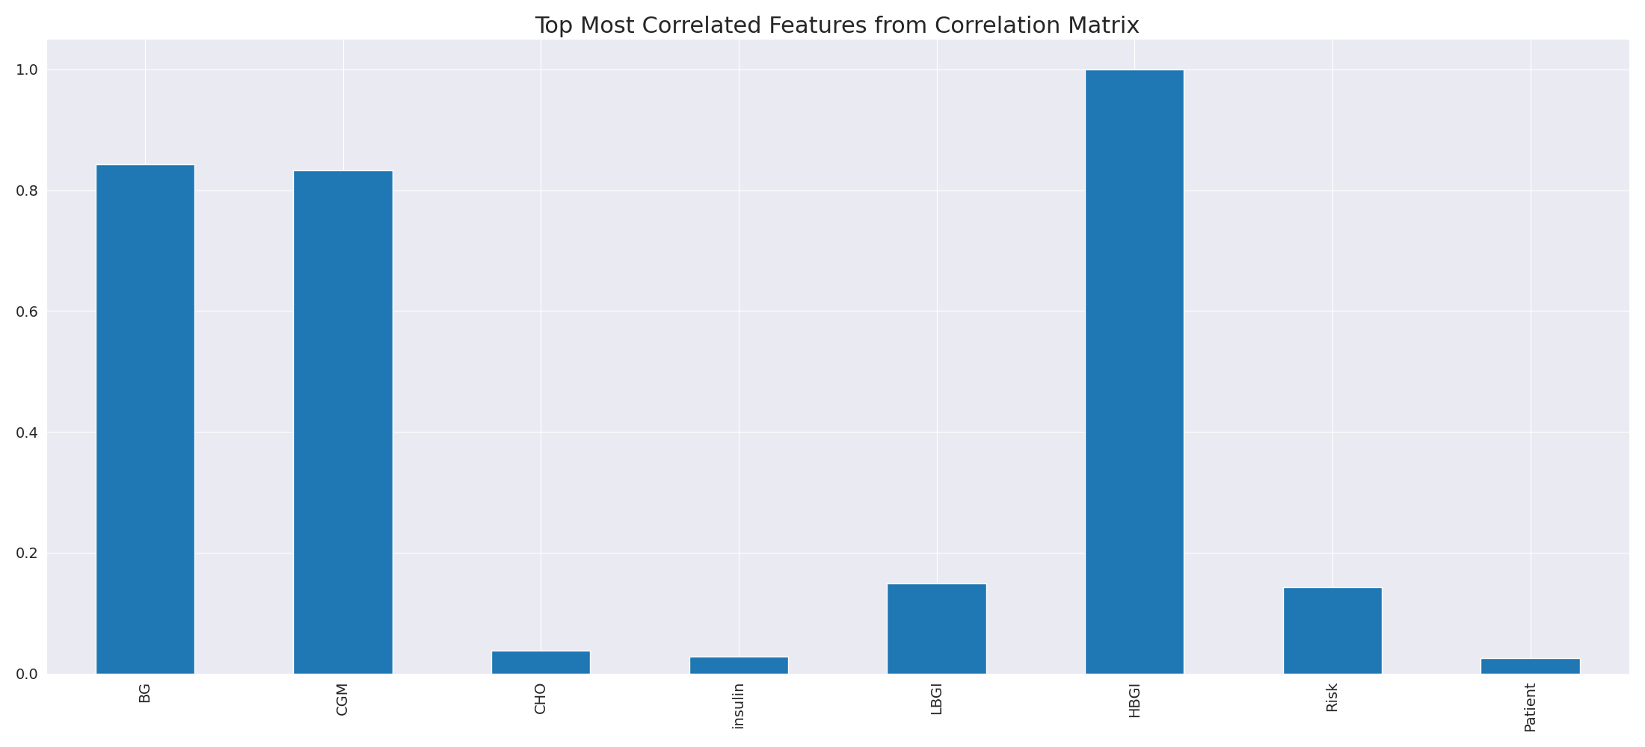

The image displays a long, blue line that represents the top most correlated features from a correlation matrix. This line is a visual representation of the strongest relationships between variables in the dataset. The line's length and position on the graph can provide insights into the interdependence of these features.  
  
The strongest correlations indicate that the variables are highly related, and understanding these relationships can help in identifying the key features that contribute to the overall performance or outcome of the dataset. This information can be valuable for data analysis, modeling, and decision-making processes.  
  
In summary, the image presents a visual representation of the most correlated features from a correlation matrix, highlighting the strongest relationships between variables in the dataset. This information can be useful for understanding the interdependence of these features and making informed decisions based on the dataset's characteristics.

Missing Numbers Graph Analysis

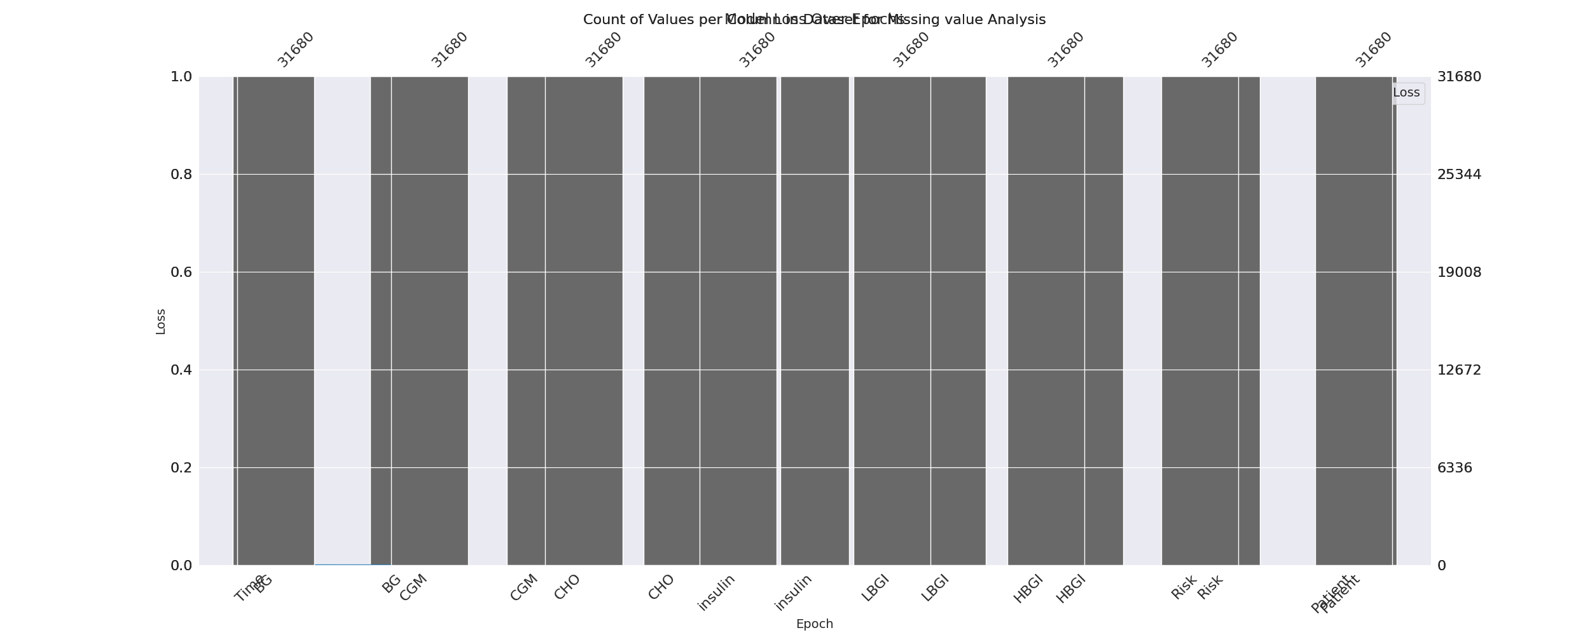

The image displays a graph with a series of numbers, including values and missing values. The numbers are arranged in a line, and the missing values are represented by a blank space. The graph is labeled with the names of the missing values, such as "missing value analysis."  
  
The presence of missing values in the data can impact data analysis or modeling in several ways. It may lead to biased or inaccurate conclusions, as the missing values could be indicative of certain trends or patterns that are not being captured. To address this issue, exploratory data analysis (EDA) techniques can be employed to identify missing values and understand their impact on the data.  
  
EDA techniques involve visualizing the data, looking for patterns, and identifying outliers. By examining the distribution of the data, one can identify the missing values and assess their impact on the overall analysis. For instance, if the missing values are concentrated in a specific region or demographic, it may be necessary to adjust the analysis to account for this bias.  
  
In conclusion, the image highlights the importance of addressing missing values in data analysis and modeling. By employing EDAs, one can better understand the impact of missing values and adjust the analysis accordingly.

Heat_Explainer Graph Analysis

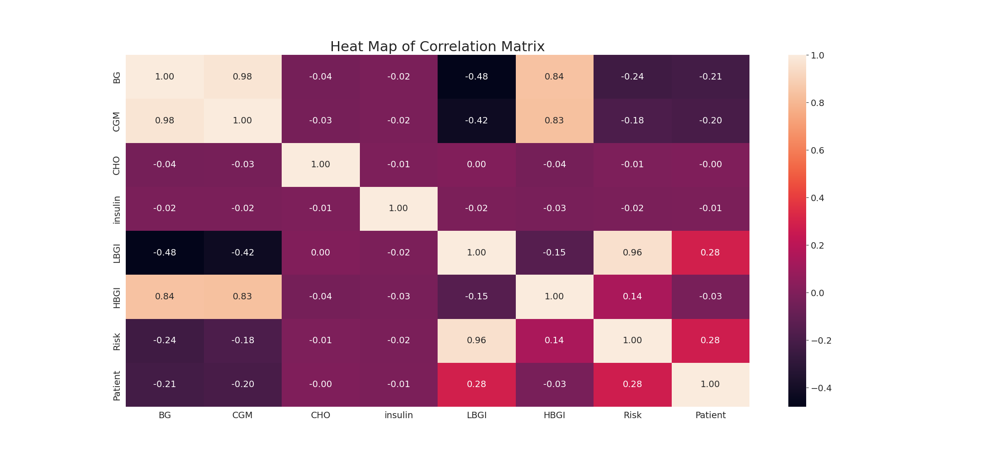

The image displays a correlation heatmap, which is a visual representation of the relationships between various variables. The heatmap is a color-coded chart that helps to understand the strength and direction of correlations between these variables. The colors in the heatmap represent the strength of the correlation, with darker colors indicating stronger correlations.  
  
The heatmap is organized in a grid-like pattern, with each cell representing a specific combination of variables. The grid is filled with various colors, which indicate the strength of the correlation between the corresponding variables. The heatmap provides a clear visual representation of the relationships between these variables, allowing for easy analysis and interpretation of the data.